……………………………………………………………………………………………………….

Linear and Nonlinear Dynamics and Vibrations Laboratory at the University of Illinois at Urbana-Champaign
http://lndvl.mechse.illinois.edu/

Current research thrusts include the implementation of passive nonlinear targeted energy transfer for aeroelastic instability (flutter) suppression, vortex-induced vibration suppression, seismic mitigation, blast protection, and vibration/shock isolation of mechanical and structural components; dynamics of nonsmooth dynamical systems, with emphasis on vibro-impacting systems and systems with friction; nonlinear system identification and reduced-order modeling; structural health monitoring and damage detection; essentially nonlinear structural acoustics of granular media; strongly nonlinear micro- and nano-resonators; nonlinear vibration energy harvesting; and theoretical studies of dynamical systems and bifurcations in higher-dimensional settings.
Fluid Mechanics Research Laboratory at the University of Illinois at Urbana-Champaign

Link from ajp
Personnel Involved in this Project:


Graduate Assistants:
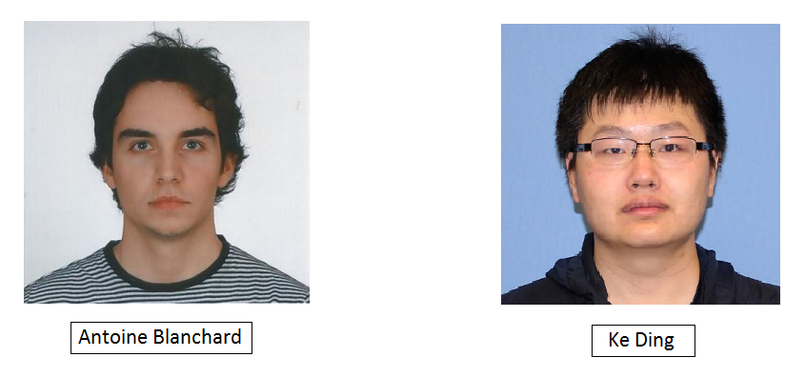

Undergraduate Assistant:


……………………………………………………………………………………………………….

